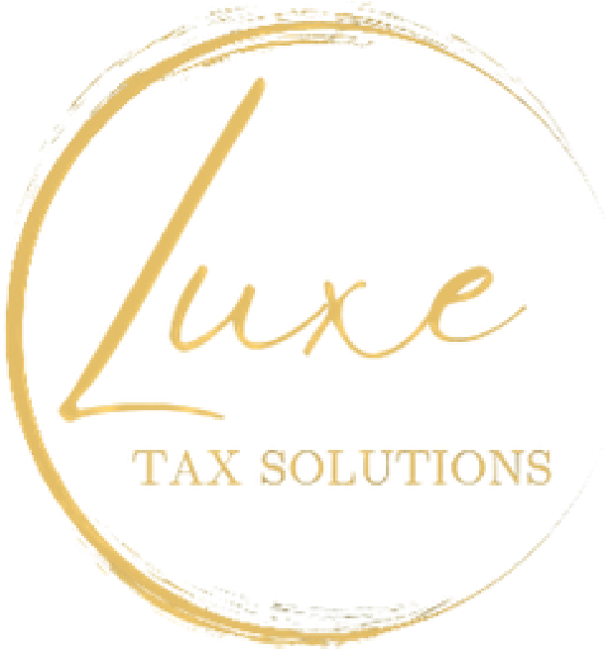
Tax Document Checklist
Thank you for choosing Luxe Tax Solutions. To ensure we can prepare your return accurately and efficiently, please bring the following documents that apply to your situation: Please include your Tax Return from the previous year.

Personal Information
- Social Security cards or ITINs for you, your spouse, and dependents
- Valid photo ID (driver’s license, passport, or state ID)
- Last year’s federal and state tax returns
- Bank account information for direct deposit or payment

Income Documents
- W-2 forms from all employers
- 1099 forms (1099-NEC, 1099-MISC, 1099-K, 1099-INT, 1099-DIV, 1099-R, etc.)
- Self-employment income records (invoices, bank statements, expense logs)
- Unemployment income (Form 1099-G)
- Social Security benefits statement (SSA-1099)
- Rental income and expense records
- Investment income (brokerage statements, sale of stocks/crypto, dividends)

Deductions & Credits
- Childcare expenses and provider information
- Education expenses (Form 1098-T, tuition, books, student loan interest) • Mortgage interest (Form 1098) and property tax statements
- Medical expenses and health insurance forms (1095-A, 1095-B, 1095-C)
- Charitable donations (cash and non-cash with receipts)
- Retirement account contributions (IRA, 401(k), etc.)
- Business or work-related expenses (mileage log, supplies, home office costs)

Other Documents
- Estimated tax payments made during the year
- IRS or state tax notices received
- Any other income or expense records not listed above
Please review this checklist carefully and gather all applicable documents before your appointment. Providing complete information helps us maximize your refund and ensure compliance.

Luxe Tax Solutions 402-979-6343

